Exercise 2: Error Handling

Scenario 1: Handle exceptions during fund transfers between accounts.
o Question: Write a stored procedure SafeTransferFunds that transfers funds between two accounts. Ensure that if any error occurs (e.g., insufficient funds), an appropriate error message is logged and the transaction is rolled back.

CREATE OR REPLACE PROCEDURE SafeTransferFunds (
p_from_account IN NUMBER,
p_to_account IN NUMBER,
p_amount IN NUMBER
) AS
v_balance NUMBER;
e_insufficient_funds EXCEPTION; -- Custom exception for low balance
BEGIN
SELECT Balance INTO v_balance
FROM Accounts
WHERE AccountID = p_from_account;
IF v_balance < p_amount THEN
RAISE e_insufficient_funds;
END IF;
UPDATE Accounts SET Balance = Balance - p_amount WHERE AccountID = p_from_account;
UPDATE Accounts SET Balance = Balance + p_amount WHERE AccountID = p_to_account;
COMMIT;
DBMS_OUTPUT.PUT_LINE('Success: Transferred $' || p_amount || ' from Account ' || p_from_account || ' to Account ' || p_to_account);
EXCEPTION
WHEN e_insufficient_funds THEN
ROLLBACK;
DBMS_OUTPUT.PUT_LINE('Error: Insufficient funds in Account ' || p_from_account || '. Transaction cancelled.');
WHEN NO_DATA_FOUND THEN
ROLLBACK;
DBMS_OUTPUT.PUT_LINE('Error: One or both Account IDs do not exist. Transaction cancelled.');
WHEN OTHERS THEN
ROLLBACK;
DBMS_OUTPUT.PUT_LINE('Critical Error: ' || SQLERRM);
END;
/
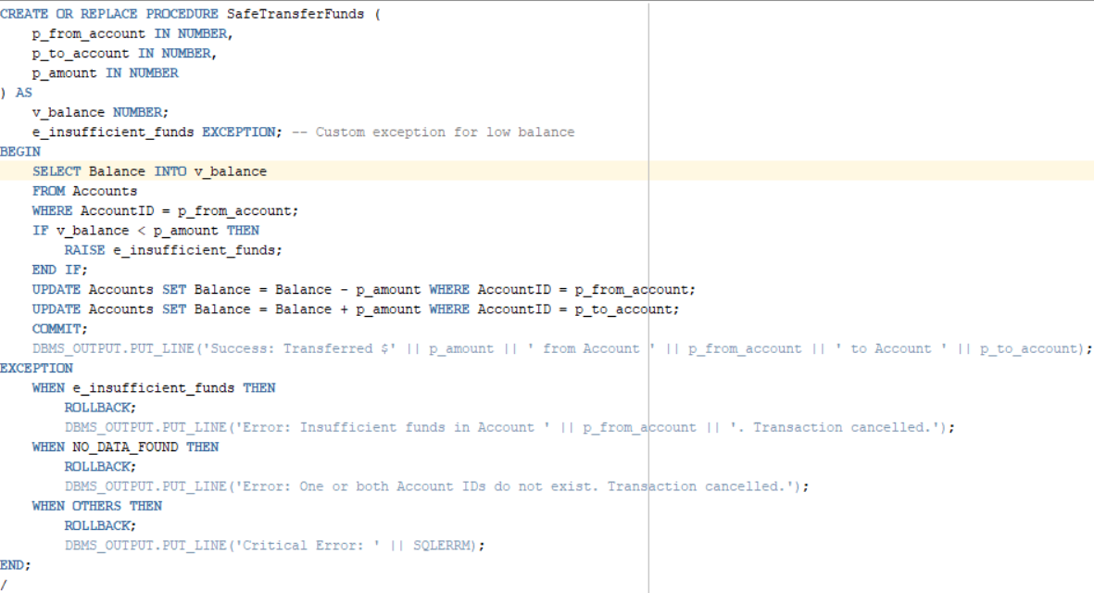

Scenario 2: Manage errors when updating employee salaries.
o Question: Write a stored procedure UpdateSalary that increases the salary of an employee by a given percentage. If the employee ID does not exist, handle the exception and log an error message.
CREATE OR REPLACE PROCEDURE UpdateSalary (
p_employee_id IN NUMBER,
p_percentage IN NUMBER
) AS
e_invalid_employee EXCEPTION; -- Custom exception
BEGIN
UPDATE Employees
SET Salary = Salary + (Salary * (p_percentage / 100))
WHERE EmployeeID = p_employee_id;
IF SQL%ROWCOUNT = 0 THEN
RAISE e_invalid_employee;
END IF;
COMMIT;
DBMS_OUTPUT.PUT_LINE('Success: Salary updated for Employee ID ' || p_employee_id);

EXCEPTION
WHEN e_invalid_employee THEN
DBMS_OUTPUT.PUT_LINE('Error: Employee ID ' || p_employee_id || ' does not exist. No changes made.');
WHEN OTHERS THEN
DBMS_OUTPUT.PUT_LINE('Critical Error: ' || SQLERRM);
END;
/
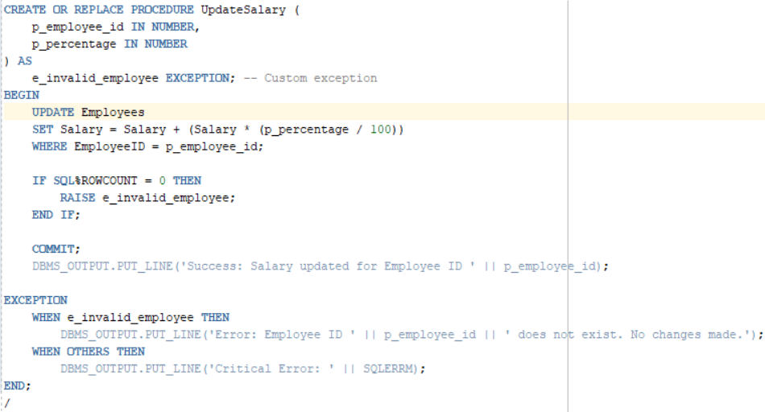
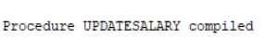
Scenario 3: Ensure data integrity when adding a new customer.
o Question: Write a stored procedure AddNewCustomer that inserts a new customer into the Customers table. If a customer with the same ID already exists, handle the exception by logging an error and preventing the insertion.
CREATE OR REPLACE PROCEDURE AddNewCustomer (
p_customer_id IN NUMBER,
p_name IN VARCHAR2,
p_dob IN DATE,
p_balance IN NUMBER
) AS
BEGIN
INSERT INTO Customers (CustomerID, Name, DOB, Balance, LastModified)
VALUES (p_customer_id, p_name, p_dob, p_balance, SYSDATE);
COMMIT;
DBMS_OUTPUT.PUT_LINE('Success: Customer ' || p_name || ' added successfully.');
EXCEPTION
WHEN DUP_VAL_ON_INDEX THEN
DBMS_OUTPUT.PUT_LINE('Error: Customer ID ' || p_customer_id || ' already exists. Insertion prevented.');
WHEN OTHERS THEN
DBMS_OUTPUT.PUT_LINE('Critical Error: ' || SQLERRM);
END;
/
